WEEK 3 -THEORY
UI Architecture - Theme, Widgets, Screens

 Learning objectives
- Structure Flutter widgets for extendibility and consistency
- Comply with coding conventions
- Create a library of generic widgets aligned with a design system
- Understand the dart concepts of static methods, attributes

How to start?
- Create a GitHub repository for this project
- Get the start code, including the Figma Design System
- Ensure you can run the start project on your computer

How to submit?
- Make sure you follow the COMMIT standards (see below)
- Push the start code into your repository (commit: BLA-000- Start Code)
- Once finished, submit to MS Team:
  - GitHub URL
  - This document

You are not allowed to use AI to submit this work

ACTIVITY 1 – Analyze the model layer

The model layer - so far - is composed of 6 classes:
Ride, Location, Country, DateTime, User, RidePref

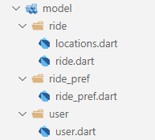

✏️ Draw the UML class diagram representing the relationships between those 6 classes.
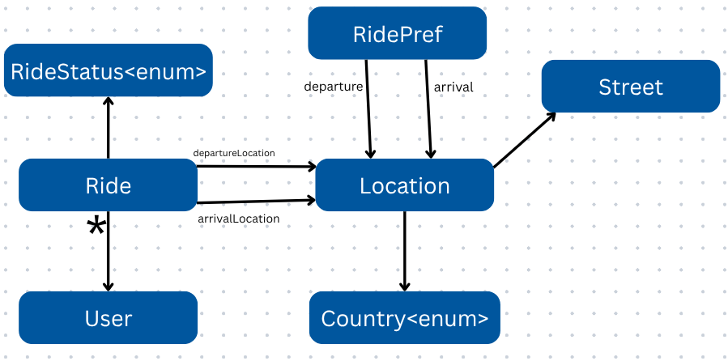
(no attribute, methods, just associations relationships)

✏️ What is the goal of the operator == and the hashCode method in Location class?
operator == defines logical equality, and hashCode ensures that equality works correctly in collections like Set and Map.

ACTIVITY 2 – Understand the difference between instance and static access

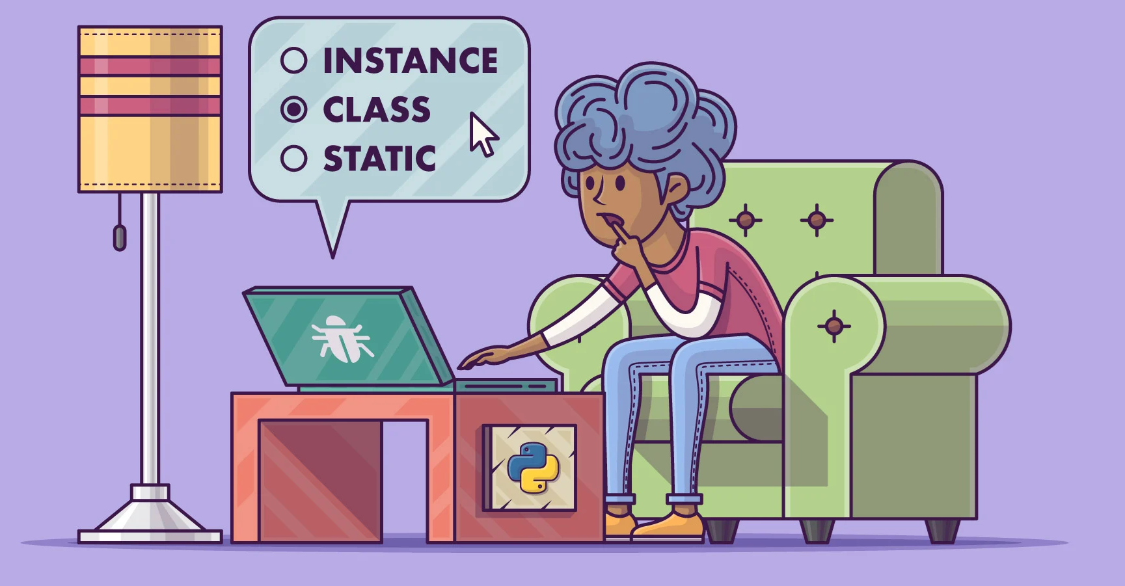
Answer the quiz in class

ACTIVITY 3 – Understand and analyze a first view: Ride Preferences screen

Let’s build step by step a Ride Preferences screen, showing only the past entered ride preferences.

✏️ Understand the methodology, steps, and coding standards to implement this view

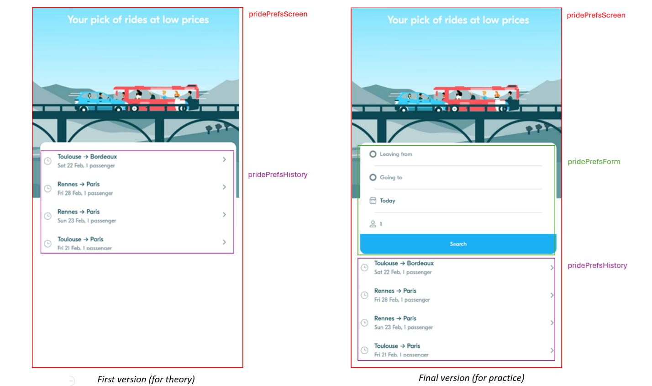

✏️Explain how the font (Eesti) is loaded from the assets and is applied to all widgets.

- The global theme sets fontFamily: 'Eesti' which makes it the default font for all text widgets
- The MaterialApp uses blaTheme, applying the Eesti font to every text widget in the app automatically

✏️ Analyze how the history tile interacts with the App theme.
History Tile | BlaTextStyle | BlaColor
title | BlaTextStyles.body(access by static method) | BlaColors.textNormal (access by static method)
subtile | BlaTextStyles.label(access by static method) | BlaColors.textLight(access by static method)

✏️Explain how the date is converted into a readable label

if (targetDate == today) {
return 'Today';
} else if (targetDate == today.subtract(Duration(days: 1))) {
return 'Yesterday';
} else if (targetDate == today.add(Duration(days: 1))) {
return 'Tomorrow';
} else {
return DateFormat('E d MMM').format(dateTime); // Example: Wed 12 Feb
}
we have a targetDate as the current date so when it meet with the Yesterday it subtract with the duration 1 days and if it meet with the Tomorrow it will add duration 1 day.

✏️ Analyze the Ride Preferences screen and complete the table.
Widget | Screen / Screen Widget /App Widget | Parameters | Callbacks
RidePrefScreen | Screen (StatelessWidget) | RidePref ridePref | onRidePrefSelected()
BlaBackground | App Widget |  | No
RidePrefHistoryTile

Note: The “RidePrefHistoryTile” doesn’t exist in the lib you provided but I see only RidePrefsService which is class not the widget it just a class.

✏️ At home, try to reproduce it by yourself (with the correction for help)

